BIRDS OF LIGHT
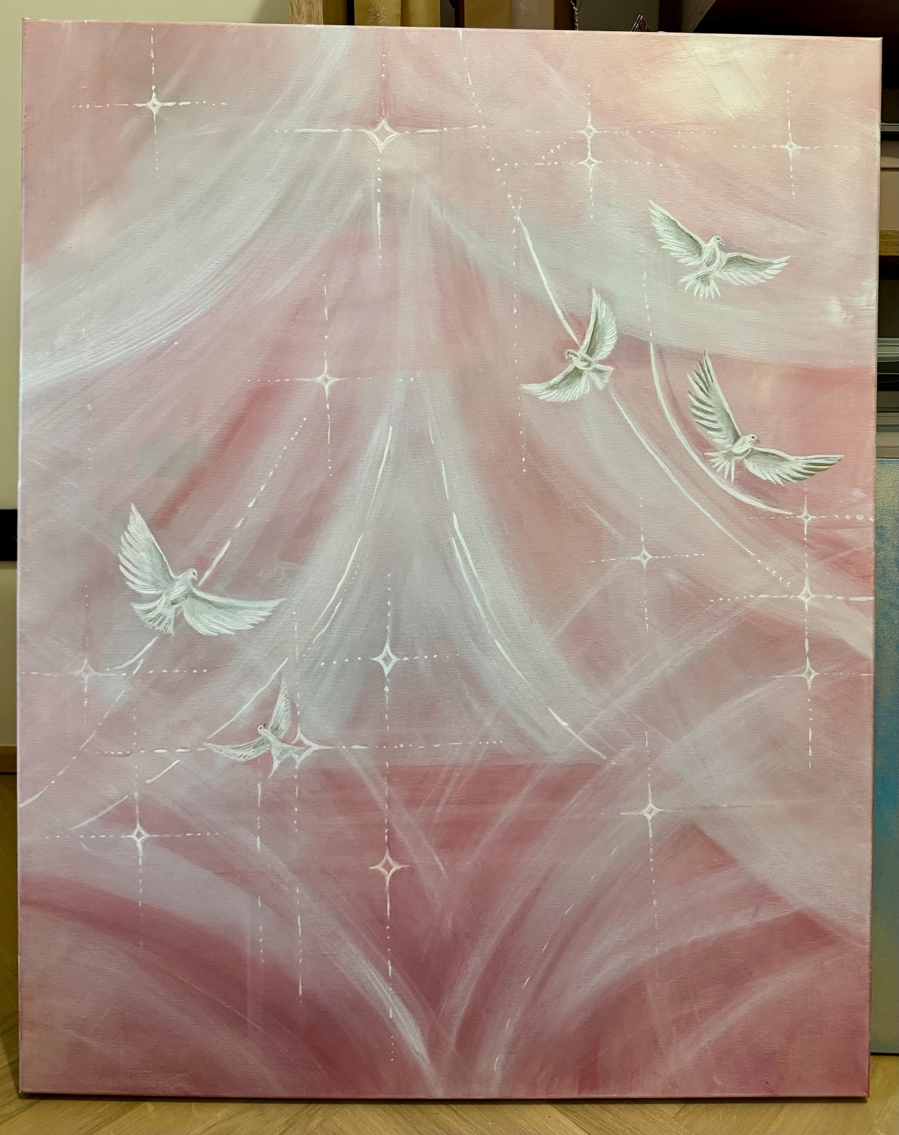

Birds of light drift through the sky,
with golden wings held open wide.
They carry dreams on winds of gold,
and stories that the stars have told.

Above the shadows, soft and bright,
they turn the darkness into light.
Their golden feathers softly gleam,
like fragments of a beautiful dream.

